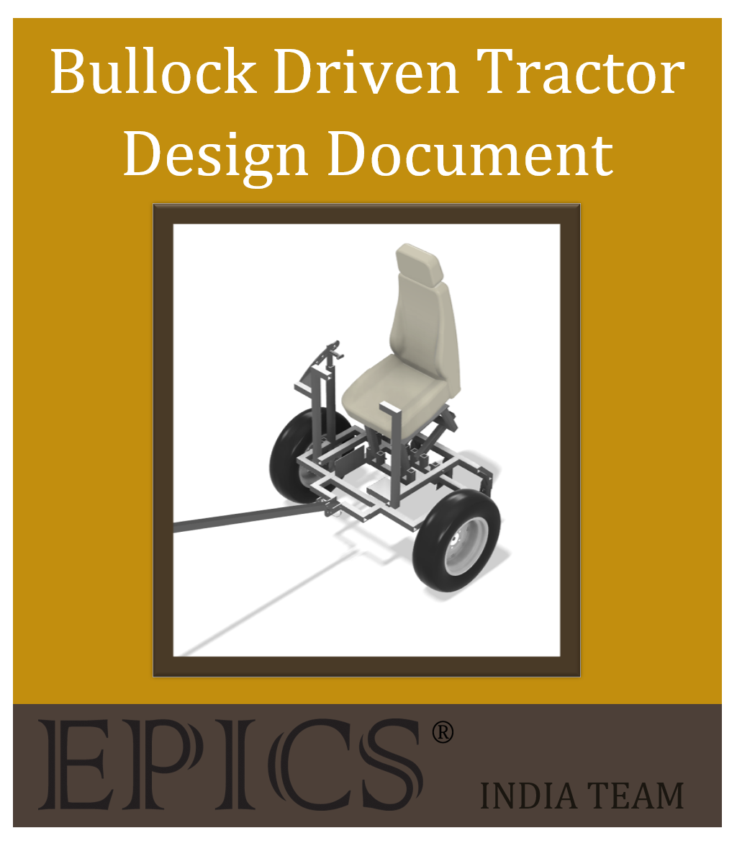

|  |
| --- |
| Table of Content |

SECTION 1: PROJECT IDENTIFICATION 3

Problem Objective Statement 3

Community Partner: RuTAG, IIT Delhi 3

Stakeholders 3

Project Scope 4

Outcomes/Deliverables 4

SECTION 2: SPECIFICATION DEVELOPMENT 5

Project Use Context 5

User Needs and Specification List 6

SECTION 3: DESIGN 7

CAD Models 7

Detailed Design Overview 10

Prototyping 11

Failure Modes and Analysis 13

SECTION 4: ENGINEERING AND ASSEMBLY 15

Bill of Materials (B.O.M) 15

Manufacturing and Assembly Process 16

SECTION 5: VERIFICATION 17

Testing Procedures 17

2. Safety and Ergonomics Testing 18

3. Dynamic Farm Testing 18

Testing Results 19

Safety and Ergonomics Results 20

Farm Testing Results 20

1. IIT Delhi: Iterated model must be created 23

2. Farmers: Attachment lifting system must be ergonomic 24

3. Farmers: Stress on bullock must be reduced 24

4. Farmers: Must be affordable 24

5. Farmers: Must be able to drive on multiple surfaces 25

6. Farmers: Can be easily used and maintained 25

7. Farmers: Durable/Will last a long period of time (5-7 years) 26

8. Farmers: Versatile for different crop types 26

9. Purdue: Future collaborations with IIT Delhi 27

APPENDIX A: POINTS OF CONTACT 27

|  |
| --- |
| SECTION 1: PROJECT IDENTIFICATION |

|  |
| --- |
| Problem Objective Statement |

To create an ergonomic and cost-effective Bullock Driven Tractor that can efficiently lift farming attachments to aid rural farmers with cultivating crops in India.

Our team from Purdue is working with IIT Delhi's RuTAG towards the common goal of improving the standard of living of rural farmers and villagers through engineering. Successful implementation of the Bullock Driven Tractor will be an important step towards improving the lives of rural farmers in India.

|  |
| --- |
| Community Partner: RuTAG, IIT Delhi |

RuTAG (Rural Technology Action Group) is an organization formed to create technologies for rural development to improve the economy and standard of living in rural communities throughout India. They identify the technological needs of different regions then formulate projects to meet these needs.

|  |
| --- |
| Stakeholders |

One of our major stakeholders is the RuTAG group at IIT Delhi. The RuTAG group already has their own solution to this problem, but they would like a fresh set of eyes on the project to see if we can create a more efficient and creative solution.

In addition, the members of the farming community and their bullocks will be affected by this project. If we can create a more efficient and cost-effective tractor, farmers will be able to cultivate crops at a faster rate. This helps the farmer be more successful, ideally improving local economies and quality of life. It will also make working conditions better for the bullocks, as having a tractor with better efficiency will allow them to work more comfortably and for longer periods of time.

The final relevant stakeholder is Purdue University, more specifically, the EPICS program. EPICS at Purdue would like a continued relationship with IIT Delhi and RuTAG in the future, which is contingent on successful project delivery.

|  |
| --- |
| Project Scope |

The team is working to improve the design of the existing Bullock Driven Tractor prototype delivered by RuTAG, which is currently implemented throughout villages in India. Successful completion of this project will consist of the following.

* Enhanced ergonomics for the rider.
  + Includes creating a lifting and locking mechanism design that allows the best user ease.
  + Includes overall comfortability of the farmer sitting on the tractor both static and in motion.
* Enhanced ergonomics for the bullock.
  + Includes force testing and comparison to typical bullock walking speeds to ensure no unnecessary strain is placed on the bullocks.
  + Includes designing the tractor to be as lightweight as possible.
* Functional in multiple farming applications.
  + Includes designing the lifting mechanism and plow spike attachments to reach into the ground at the depths required for (primarily) wheat and rice.
* Cost Effective.
  + Includes using materials for the design that are accessible and inexpensive in India.
  + Includes tracking purchases for prototypes and a running bill that demonstrates potential costs for the tractor.
  + Includes taking inflation of certain materials into account.

We will not be considering electrically powered tractors due to their high cost an impracticality for rural farmers in India. The Bullock Driven Tractor is more realistic and more common within rural communities, which is why the design created by our team will be based on this idea. The goal is to create a simple, effective design that farmers will be able to operate and maintain with ease.

|  |
| --- |
| Outcomes/Deliverables |

The team must create a tractor that adheres to the user’s needs and successfully completes the goal created by the problem statement. Prototyping and testing will necessitate a physical prototype, but the actual deliverables that will be given to the project partner at project completion are all digital. The following documentation is required to commence project delivery.

* Delivery Design Document
  + The goal of this document is to define the project, then provide insights and justifications on iterated designs.
* User Manual
  + The goal of this document will provide instructions on how to use and maintain the tractor.
* Manufacturing Document – CAD Models and Drawings
  + The goal of the drawings is to provide the blueprints for the project. CAD drawings will act as the sole guidance on how the tractor will be built. 2D and 3D models will be delivered for each individual component as well as the full assembly.

|  |
| --- |
| SECTION 2: SPECIFICATION DEVELOPMENT |

|  |
| --- |
| Project Use Context |

The Bullock Driven Tractor is going to be primarily used by farmers in the northwestern region of India. It is intended to help the farmers tend to their soil by utilizing plow spikes which can be attached to the back of the tractor. Ideally, using our Bullock Driven Tractor will significantly facilitate the process, allowing it to be more efficient, cost-effective, and less strenuous for the farmers.

The first major consideration regards tractor storage and exposure. Ultimately, the space will vary and depend entirely on the storage availability of each owner. Optimally the farmer will have at least a 4x4 foot sheltered area to store the tractor, however, it is possible that the tractor will instead reside outdoors when not in use for ease of access or lack of shed space. This means the tractor will need to be able to withstand environmental conditions such as intense sun and monsoon weather. Understanding and extending the lifespan of the tractor largely depends on the weathering it may undergo.

In terms of safety precautions, the tractor shouldn’t be exposed to the public as it will reside on the farmer’s personal property. One caveat is that children of the farmer may be exposed to the tractor depending on the farmer and the rules that they enforce. For this reason, the tractor must be safe when stationary (or in storage). Safety of the user and bystanders must be accounted for and mitigated.

One of the primary societal factors to take into consideration is the economic situation of the farmers. Many of these farmers do not have the ability to spend money on unessential items. This means that for our project to benefit them, it needs to be affordable and helpful enough to justify the cost.

Additionally, the farmers in India have great respect and appreciation for their bullocks. Creating a tractor that treats the bullock well (i.e. not overloading or adding unnecessary strain) is an essential factor to incorporate into our design.

The final consideration regards potential limitations we might face when it comes to materials and mechanisms. Many farmers live in relatively secluded areas, so technology and materials we can use are limited to what is immediately/readily available within the region. Keeping affordability in mind, solutions and design decisions must be made conscious of the economic state of the local region and current costs of materials.

|  |
| --- |
| User Needs and Specification List |

The stakeholders outlined earlier in this section have a list of needs that will need to be fulfilled by our design. The following needs are numbered and outlined below; each stakeholder for each need is defined, as well as the requirements derived from the needs. The requirements will serve as our goals in design and will be thoroughly tested to ensure user needs will be met. Benchmarking and success of our project will largely be based on the ability to meet and/or exceed the requirements.

| **Need #** | **Stakeholder** | **User Need** | **Requirements/Specifications** |
| --- | --- | --- | --- |
| **1** | IIT Delhi | Iterated model must be created | A full prototype should be documented in CAD 3D models and drawings. |
| **2** | Farmers | Attachment lifting system must be ergonomic | The lifting mechanism must be able to carry 60-70kg without unreasonable physical exertion. |
| **3** | Farmers | Stress on bullock must be reduced | Prototype force testing will be done to analyze potential strain on bullocks. The force of a bull must be calculated and considered in testing. |
| **4** | Farmers | Must be affordable | The tractor should not exceed Rs. 25,000. Materials and inflation must be accounted for. |
| **5** | Farmers | Must be able to drive on multiple surfaces | Testing on surfaces such as grass, gravel, exposed dirt, etc. will be done to determine versatility. |
| **6** | Farmers | Can be easily used and maintained | Design must be intuitive, and maintenance should be straightforward. A user manual should be created and translated into the local language. |
| **7** | Farmers | Durable/ Will last a long period of time (5-7 years) | 5+ year testing is unfeasible for our team, but wear over time and long-term use ergonomics will be considered and accounted for. |
| **8** | Farmers | Versatile for different crop types. | Several different heights must be attainable by the lifting mechanism. Depth control for wheat and rice will be implemented into the design. |
| **9** | Purdue | Future collaborations with IIT, Delhi | The team must keep consistent communication with the project partners and ensure design delivery is done smoothly. |

Table 1: Stakeholder Needs and Derived Specifications

|  |
| --- |
| SECTION 3: DESIGN |

|  |
| --- |
| CAD Models |

The figures below are labeled and numbered for future reference throughout this and later sections. Each drawing and model were created in Fusion 360. The first figure shows a full drawing of the tractor with labeled sections. The following figures are rendered models of specific sections.

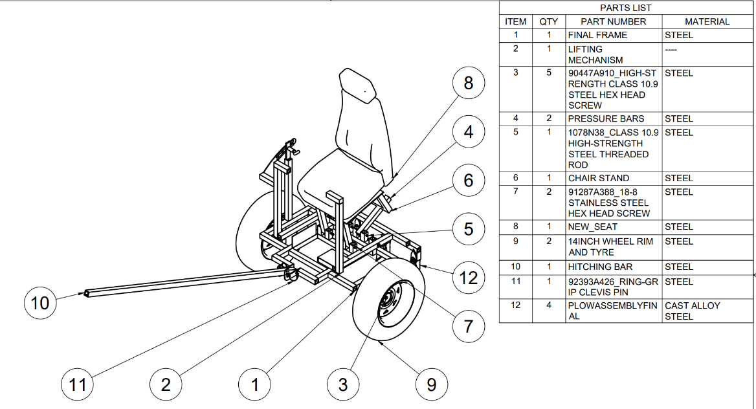Figure 1: Full Drawing

|  |  |
| --- | --- |
| Figure 2: Full Model, Front Perspective | Figure 3: Full Model, Back Perspective |
| Figure 4: Frame | Figure 5: Lifting Mechanism |
| Figure 6: Locking Mechanism | Figure 7: Spring Plunger |
| Figure 8: Plow Spike Attachment | Figure 9: Seat Attachment |

|  |
| --- |
| Detailed Design Overview |

Though the main task given to us by RuTAG was locking mechanism iteration, we also created slight modifications to sections such as the lifting mechanism and plows. RuTAG can analyze our designs, prototyping, and testing results and determine which iterations should or shouldn’t be included in the final design they produce.

When the EPICS team was tasked with iterating the design the focus fell on the locking mechanism. The goal was to generate a design that would be more ergonomic and easier for the farmers to use. Many options and possibilities were considered but were narrowed down to four and evaluated in a weighted decision matrix. The spring plunger was considered the best option given factors such as feasibility, locking ability, and overall accessibility. Certain categories where the final choice fell short were safety, lifespan, and maintenance ease, which were considered and mitigated in designs.

Figure 10: Decision Matrix for Locking Mechanism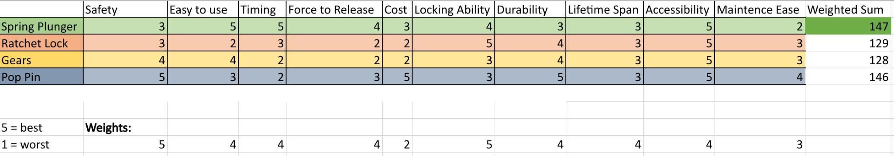

The spring plunger is designed as a connection point between the frame and lifting mechanism. The spring plunger is welded onto the frame’s vertical bar which can be pulled in and out of the lifting mechanism’s arc bar. There are several different heights that directly correlate with the lifting mechanism’s intended heights.

The frame is the base of the entire tractor, consisting of the hitching attachment, wheel assembly, and seat attachments. Several horizontal bars are welded to provide stability, and vertical bars for component attachment points. The front of the frame has an “L” shaped design for angled hitching, with multiple height options; the hitching medium is simple steel tubing. Hitching to the bulls will be determined by the project partners. On either side of the tractor are wheels that are adjustable to two different heights. They are attached by different axles, meaning that the turning of one wheel can be independent of the other, allowing better mobility and smaller turning radius. A foot protector can be noticed on the right-hand side of the user which is meant to mitigate a pinch point between the lifting mechanism and the frame and is high enough to mitigate a shear point. In the center of the frame is the seat and lifting mechanism attachment points. The vertical welds allow full movement of the lifting mechanism and stability for the front seat’s legs.

The lifting mechanism is controlled by the locking mechanism, allowing 4 different plow depths. One of these heights pulls the plow spikes entirely out of the ground for turning purposes. The user would presumably be riding with the right foot on the frame, and the left foot set on the lifting mechanism’s flat footrest, with both arms holding onto the handles. When changing heights, the user will pull the spring plunger out and keep the lifting mechanism stable with the left foot. Pressing down on the footrest and forward on the handle pulls the spikes further out of the ground. Pulling back on the handle and lightening the pressure on the footrest will push the spikes further into the ground.

Plow spikes themselves should be bought directly from manufacturers, and are expected to be replaced as needed, given how quickly they wear out. The plow spike attachments are designed to facilitate the exchanging of these spikes, and account for double-sided spikes (which allow 2 full uses of 1 spike). A diagonally cut piece of square tubing is welded onto vertical square tubing, with one bolt welded between them. This design prevents deflection and provides a straightforward way to exchange worn out spikes. There are four equidistant attachment points along the bottom of the lifting mechanism.

|  |
| --- |
| Prototyping |

A fully prototyped tractor has been created to allow in-depth testing of ergonomics, usability, and safety, both dynamic and static. This project necessitated a fully functioning prototype so that the design could be fully created and verified before the final delivery.

The final prototype itself is constructed of steel, aside from the wheels and seat. Figure 11 below demonstrates the final tractor prototype with and without a rider.

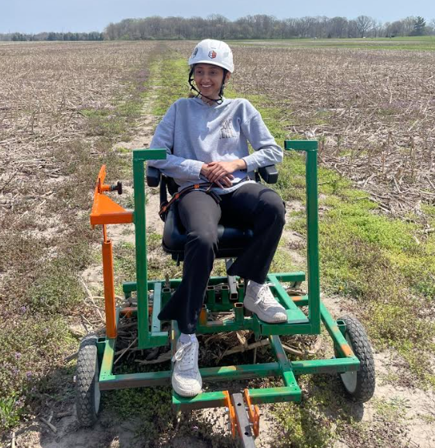 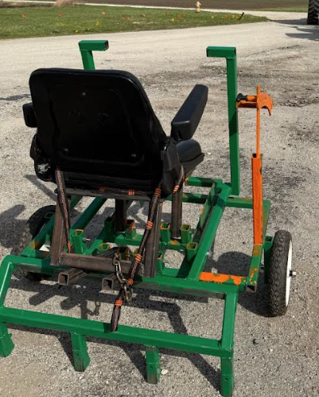

Figure 11: Completed Prototype

Before finalizing a design and implementing it to the final prototype, components were visualized using materials such as cardboard and wood. This allowed us to brainstorm and conceptualize improvements before they became permanent decisions. Figures 12 and 13 show examples of wood and cardboard prototypes, respectively.

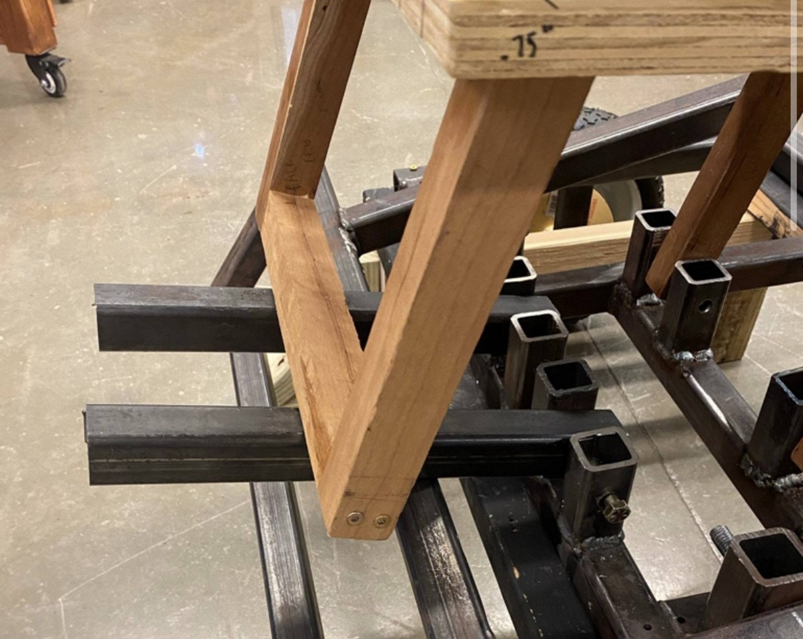 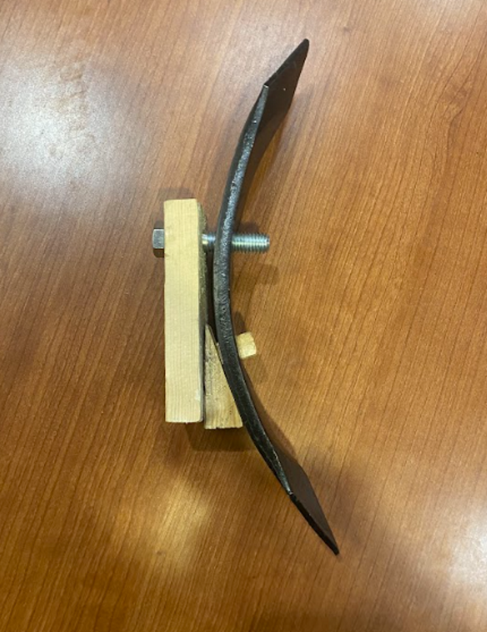

Figure 12: Wooden Prototyping Examples

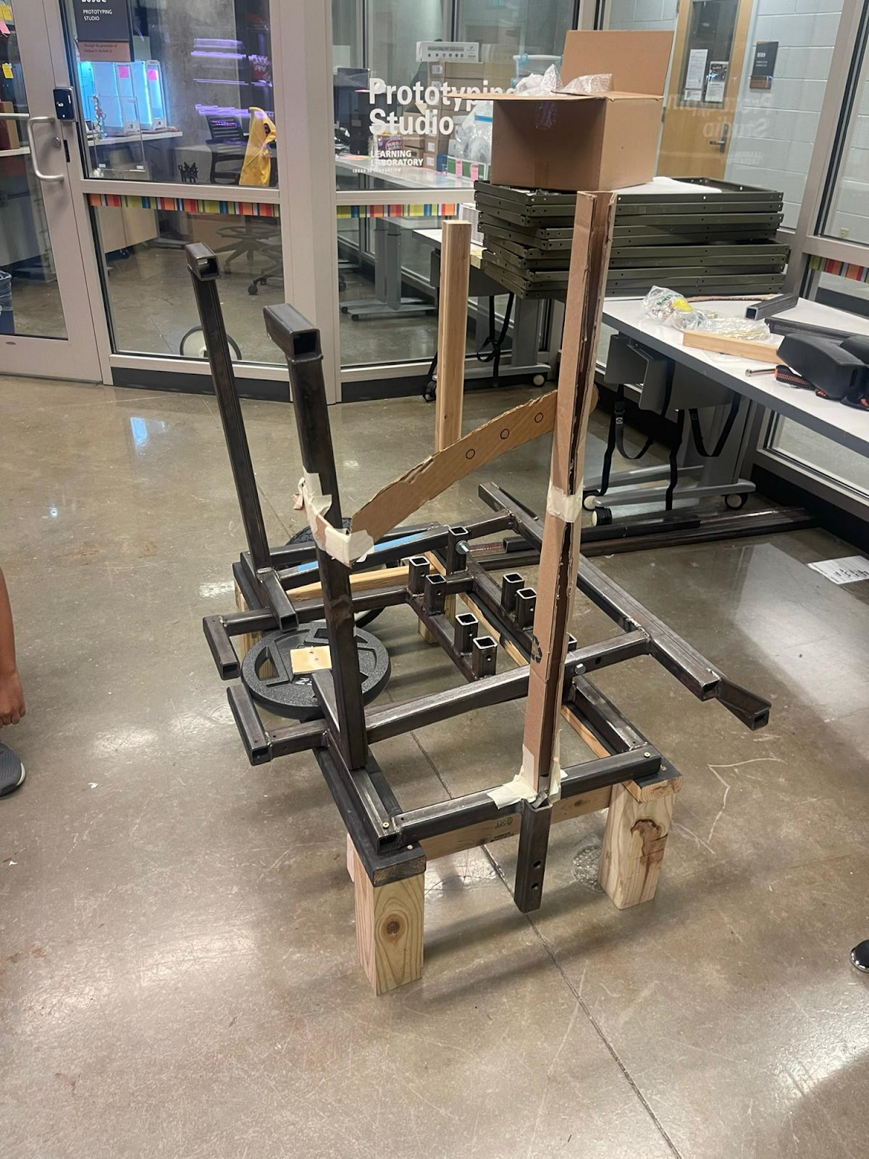

Figure 13: Cardboard Prototyping Example

For keeping the tractor stable in static testing, a testing rig was created out of leftover wood in the lab (see Figure 14). This testing rig has proved sturdy and a valuable mount for when the tractor is not being transported or dynamic tested. There is potential for a farmer to use such a mount for storage; it does, however, take much strength and more than one person to take the tractor on and off the rig.

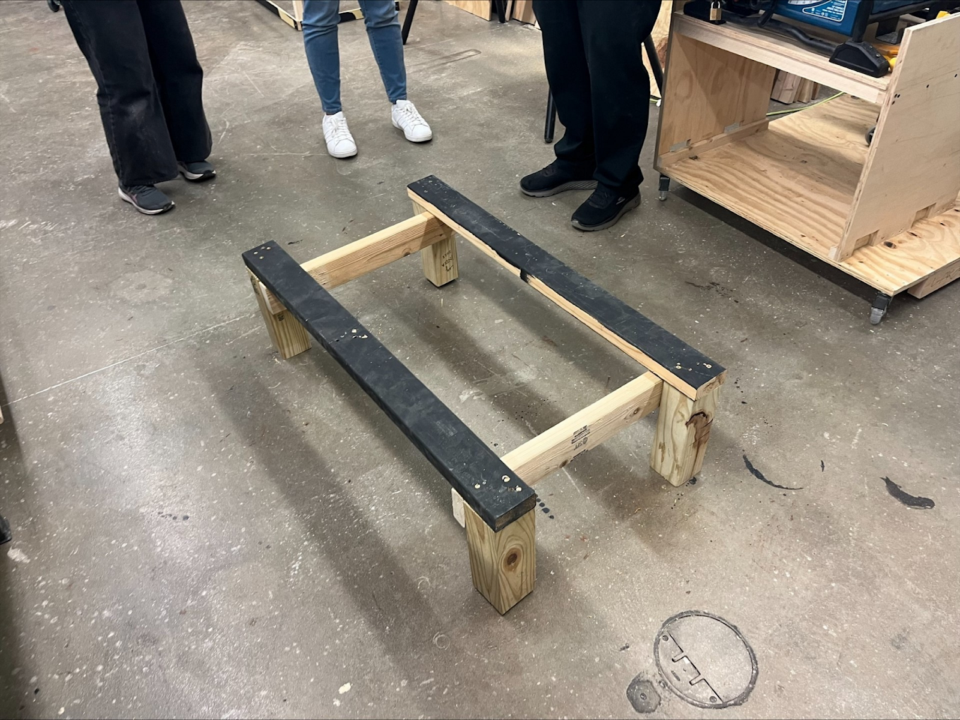

Figure 14: Testing Rig

|  |
| --- |
| Failure Modes and Analysis |

Potential sources and causes of project failure have been defined, outlined, and discussed in the chart shown in Figure 15. The most notable points regard safety concerns such as the farmer falling off the tractor seat and a couple pinch points between the lifting mechanism and frame. These concerns will be mitigated by implementing measures such as a seatbelt and extended footrests (to guide foot placement). Another important failure mode is the locking mechanism. Deflection and weathering may cause issues over time which would render the whole mechanism useless. These issues will be mitigated by designs that discourage deflection and allow easy access and exchange of worn springs in the spring plunger.

The FMEA chart demonstrates how important modes of potential failure have been acknowledged and accounted for in the final tractor design. After mitigation plans and implementations, there is no likelihood of any failure mode greater than 5.

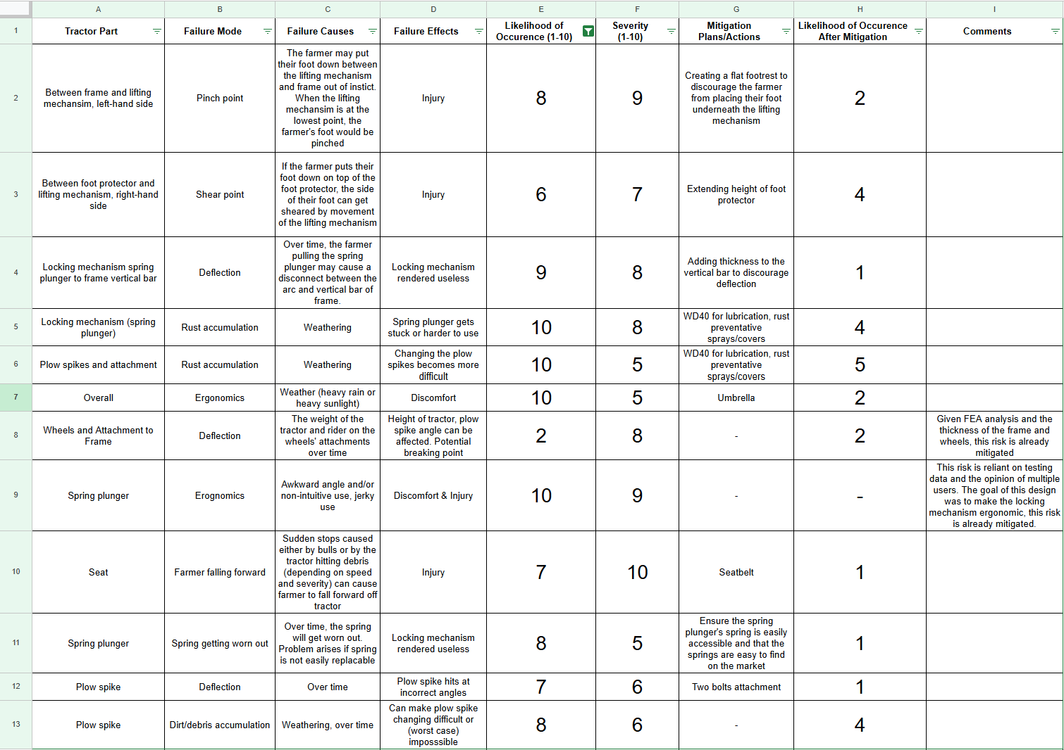

Figure 15: FMEA Chart

|  |
| --- |
| SECTION 4: ENGINEERING AND ASSEMBLY |

|  |
| --- |
| Bill of Materials (B.O.M) |

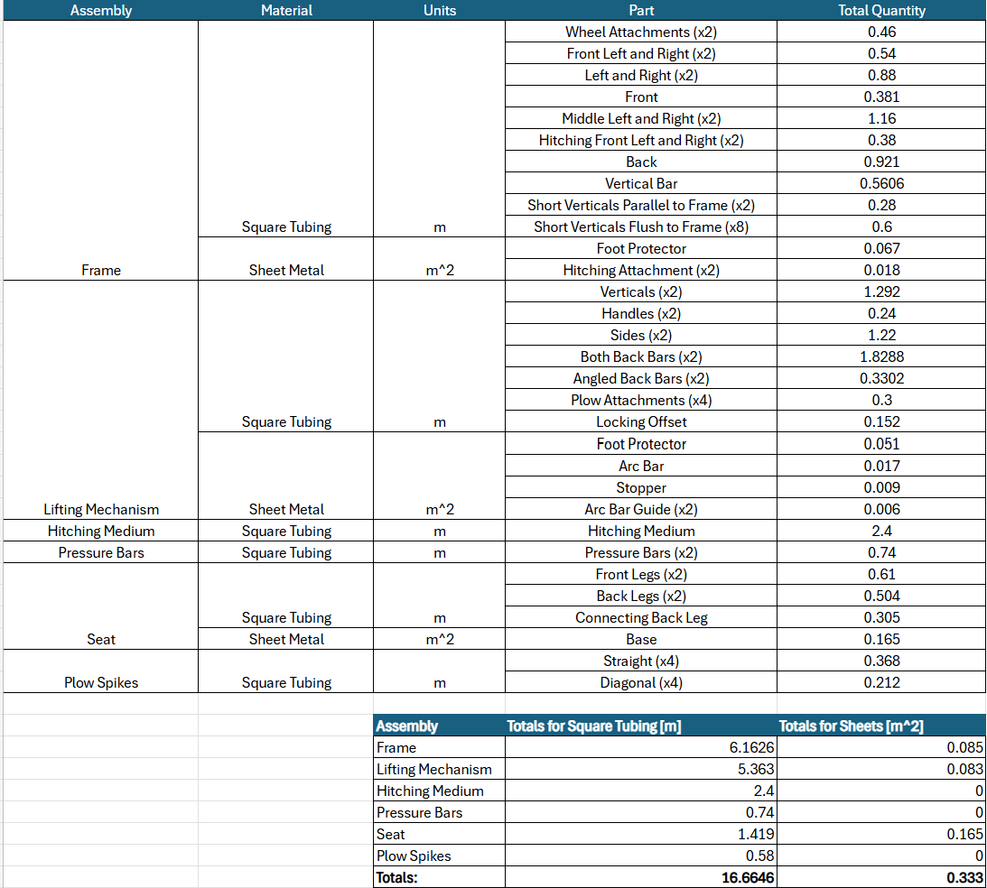

Figure 16: Materials Totals

For calculating the estimated cost of the tractor, the individual materials (square tubing and sheet metal) were first broken down, as seen in Figure 16. This helps provide context for the totals shown in Figure 17.

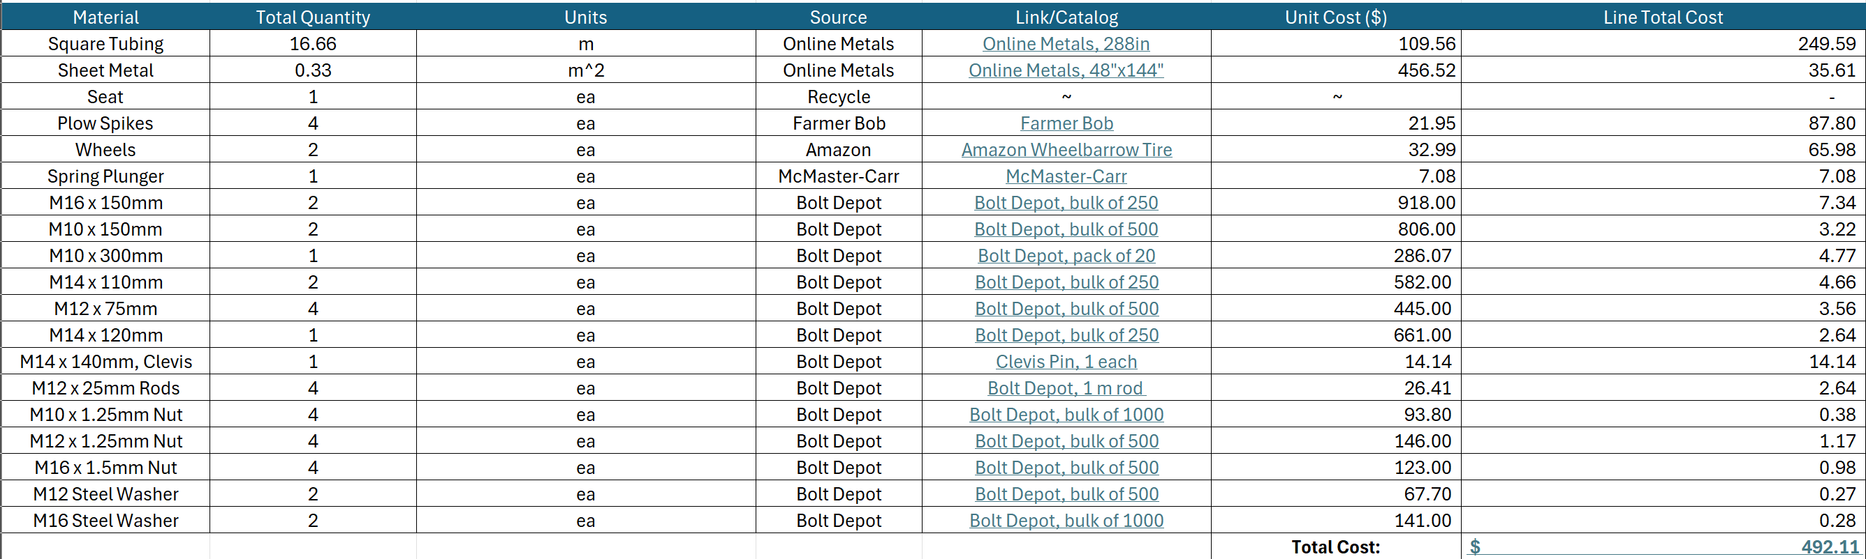

Figure 17: Bill of Materials

The tractor’s final estimated cost appears to be around $492.11, or Rs. 41,640.87. This value is exceptionally higher (by 66.67%) than the intended budget of Rs. 25,000, though there are many reasons and several justifications for such a high cost.

The first major factor is the unforeseen inflation in steel inflation in the U.S., and the overall locality of these materials. The start of this project was in 2019 and has since exceeded the initial timeline, thus, the large increase in steel prices wasn’t fully accounted for. It is also understood that the cost of steel is much lower in India, which would greatly reduce the cost of production, since 57.95% of the total cost is steel. Another large contribution to the cost lies in the wheels. The seat is expected to be recycled, which is an option that can be considered for the wheels, such as from old wheelbarrows or other tractors.

Aside from steel, there are large fluctuations in price between American manufacturers. When the B.O.M. was initially created, it depended fully on Amazon purchases, which provided a cost that totaled over $900. Resourcing these materials provided the final B.O.M. seen in Figure 17, but even these sources could be less than ideal.

While the B.O.M. totals are concerning, they are only an estimate based on American manufacturers. Due to these fluctuations in sources and the understanding that steel prices in India are much lower than in the United States, it is not definite that our costs exceed the initial budget by a large amount.

|  |
| --- |
| Manufacturing and Assembly Process |

Many manufacturing and assembly practices were used to manufacture the prototype, all of which should still be available locally. The main processes are as follows.

* Welding: MIG and Stick
  + Welding steel on the prototype was done at our manufacturing center on campus. Switching between MIG and stick methods happened due to the availability of the welding cell. Any welding method (MIG, stick, or other) is practical to join joints and components.
* Sanding
  + The Tractor was sanded to allow better spray paint adhesion. This process was done using an angle grinder with a sanding attachment.
* Spray Painting
  + The tractor was sprayed to prevent rust accumulation over time and general weathering. Any color or type that ensures rust accumulation will not happen is practical.
* Overhead Drill Press and/or Power Drill
  + Drills were used to create holes in the steel tubing to hold bolts. An overhead drill press provides more precision in size and consistency, but a handheld power drill was used in many instances, such as the arc bar on the locking mechanism. Any drilling process is feasible.
* Horizontal and/or Vertical Bandsaw
  + The bandsaws were used to cut the steel tubing. The angle can be adjusted and account for sloped components such as the plow spike attachment and lifting mechanism.
* Laser Cutting and/or Water Jets
  + Both processes were utilized to cut steel plating for components like the footrest and stopper for the locking mechanism. Either process (or related) is practical for steel plate cutting.
* Sheet Metal Bending
  + One specific component that requires this is the sloped footrest on the lifting mechanism. Any type of metal bender will be practical due to the pliability of the used sheet metal.
* Assembly
  + The full assembly is put together using nuts and bolts. Minor caveats to this are the hitching which uses a clevis pin, and the spring plunger application. All constraints regarding bolt sizes should be provided above.

|  |
| --- |
| SECTION 5: VERIFICATION |

|  |
| --- |
| Testing Procedures |

Testing was conducted in three primary categories to ensure comprehensive validation of the design and verification of the user’s and stakeholder’s needs. The following are the methods of collecting data.

**1. Finite Element Analysis (FEA)**

FEA was run in Fusion360 to determine where potential deflection may occur and how much force certain joints can take before they reach breaking points. Static analysis focused mainly on the frame, lifting mechanism, and locking mechanism, onthe following factors.

* Stress concentration analysis at critical welding points.
* Deflection analysis of the locking mechanism vertical bar.
* Load distribution analysis for seat and lifting mechanism.

### 2. Safety and Ergonomics Testing

This test is meant to ensure the tractor is safe to use in terms of both short-term and long-term risks to the rider. These tests were very qualitative and relied on getting feedback and iterating on the design as the prototype was built. This testing is largely analyzing the tractor while it is static, either on the testing rig or otherwise held still.

* Potential hazards including pinch points and shear points were noted and mitigated as noticed.
* Members of the team of different heights and weights tested the tractor to provide feedback on comfort, functionality, and any noticeable strain or excessive exertion while using the locking mechanism.
* With different users testing, intuitive placements of hands and feet, as well as intuitive use of the lifting and locking mechanisms was observed.

### 3. Dynamic Farm Testing

Functionality testing of the full tractor was necessary to ensure good ergonomics and safety of the tractor in-use, providing more quantitative data and tangible results.

* Comfort in riding the tractor was tested both when the plow spikes were out of and in the ground. This test observed how smoothly the tractor ran at different heights and ground types.
* The drag at different plow spikes heights was assessed and its effects on the overall tractor movements were analyzed.
* Debris and dirt build up under the lifting mechanism and the effect it had on drag was also analyzed.
* The force of the tractor as it accelerates from 0mph to ~3mph was measured.
* The radius of the tractor’s turns was measured.
* The plow spikes resilience (how worn and/or chipped they were) after a long testing session was observed.

|  |
| --- |
| Testing Results |

**FEA Results**

The team conducted static loading tests on Fusion 360 on key individual components such as the lifting mechanism and frame which will face the most significant loading to ensure that no permanent deformation would take place (as shown in figure 18). Placed loads greater than anticipated 1000N for each point of force and found it have a factor of safety greater than 7. These results verified that the design could handle much greater force and still not be susceptible to deformation or buckling.

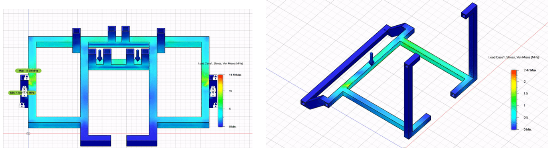Figure 18: Static Testing FEA Results on Individual Components of Assembly

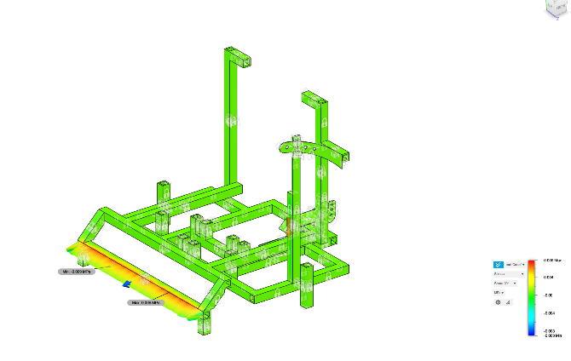

Figure 19: Full-Assembly Dynamic Testing FEA Results

Conducted similar FEA testing on the full assembly and found the peak deflection is just under 0.09mm —the exact region where the spikes penetrate the ground—while the remainder of the frame deflects by less than 0.05 mm. To reduce rotational compliance at this critical interface, two high-strength bolts have been added on either side of the spike mount, significantly increasing local rotational stiffness and limiting moment-induced movement.

### Safety and Ergonomics Results

This testing yielded valuable feedback that allowed the team to improve upon the design throughout the prototype’s construction.

* Many relevant failure modes or hazardous components were noted and analyzed for severity, likelihood, and effects. Specifics are noted in the FMEA shown previously in Figure 15. This FMEA was created and consulted throughout the prototype creation, so risks of injury and tractor failure could be mitigated. Some of the most relevant implementations have been the footrest and foot protector, both of which mitigate shear and pinch points.
* Throughout the project’s timeline, many members have come and gone, but all have had a chance to test the ergonomics of the tractor either static or in motion. No members have complained of general discomfort sitting in the seat or discomfort in placing their hands and feet in the intended places, while the tractor was on the testing rig, not moving. The shortest user was just under 5ft, and the tallest was over 6ft. There were some issues regarding the smoothness of the locking mechanism, which was noted by the testers. User concerns about the spring plunger getting unstuck and sliding too much across the arc bar has been mitigated by adding guides to the top and bottom of the arc bar.
* Intuition of the project was also observed during these static tests with different members. Foot and hand placement, as well as the locking mechanism will be described in the User Manual, but the actual design should still be intuitive. New members, who were previously unfamiliar with the project, were able to test it and give feedback on how the design could be improved. For example, one teammate found that he intuitively placed his foot on top of the foot protector, which could lead to a potential shear point. This risk was analyzed and mitigated by increasing the height of the foot protector, so the foot easily rests more comfortably on the frame, where it is intended to be.

### Farm Testing Results

Farm testing results yielded much clearer results on the functionality of the tractor. Purdue ACRE fields were used for testing, though the ground had excessive debris, dry crops, and dry soil; no other fields were open for the team to use. A vehicle was also used to pull the tractor, a KUBOTA RTV-X900GH.

* The tractor proved to pull consistently across the dry crops, even given the excessive friction. Bulls are extremely strong but will have strengths that vary between each animal.
  + Plow spikes 2in. into the ground (initial pull): 439.93N.
  + Plow spikes 2in. into the ground (at 3mph): 326.94N.
  + Without plows engaged on smooth ground: 94.75N.
* On flatter, smoother ground the force of pulling the tractor was better observed and appeared to be about 96.05N, or 0.1288hp. The typical speed and power of a bull are shown below, demonstrating much leniency in power and force.
  + Maximum speed: 3mph.
  + Maximum power: 0.5hp.
* Members who sat on the tractor did not feel any discomfort, even achieving speeds over 3mph. Sudden stops were also tested, and the riders did not appear to jerk forward too harshly.
* The turning radius is very sharp given the independent turning of both wheels; the tractor could turn entirely on the axis of one wheel.
* Debris built up was noted to be very excessive but could be due to the unique testing environment. The debris buildup can be seen below in Figure 20. The spikes were very easy to clean out by hand or other tools, however.

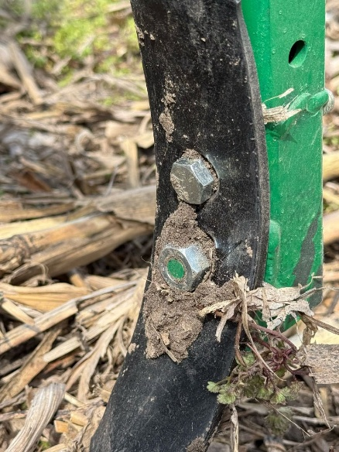  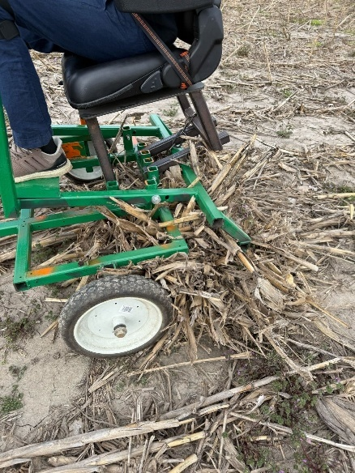

Figure 20: Dirt and Debris Build Up on Plow Spikes

* The plow spikes can reach into the soil from 1-2in., as shown in Figure 21. Redesigns of this plow attachment component can be easily modified to allow the spikes to further reach into the ground.

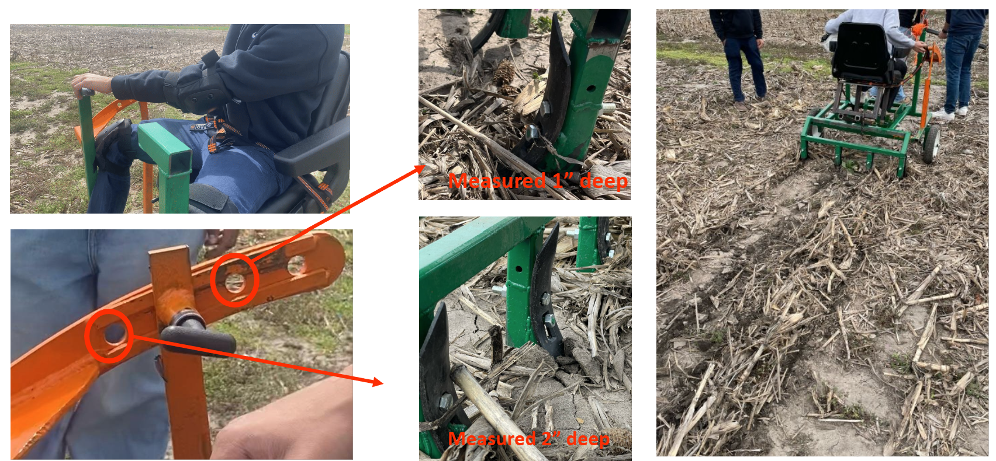

Figure 21: Plow Spikes in Ground

* After a full day of testing, the chipping and wear on the plow spikes was very minimal. Longevity testing over many months and years of the plow spikes cannot be feasibly done by the team.
* Further testing setup and images can be seen in Figure 22– Figure 23.

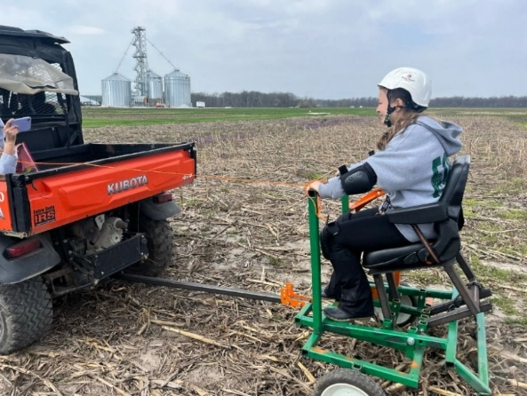

Figure 22: Tractor Connection with RTV

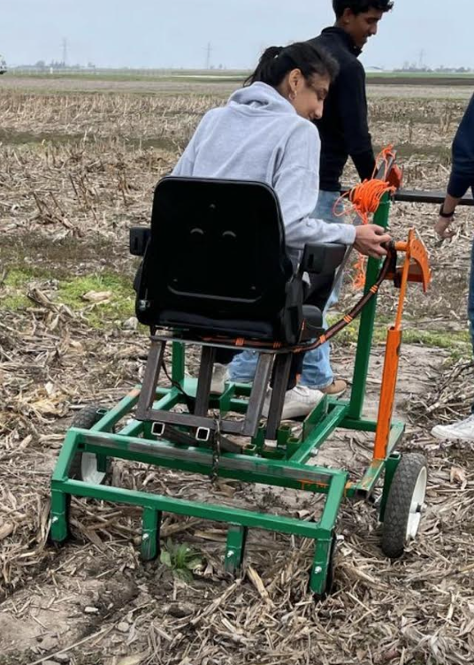

Figure 23: Using Locking Mechanism to Change Heights

|  |
| --- |
| **Verification of User Needs** |

This section details how each user needs and corresponding requirement has been verified through testing, analysis, and design implementation.

### 1. IIT Delhi: Iterated model must be created

**Requirement:** A full prototype should be documented in CAD 3D models and drawings.

**Verification:**

* Complete CAD models have been created in Fusion 360 and shared in the final delivery for all necessary components of the tractor.
* Detailed drawings with proper dimensions have been finalized for the frame, lifting mechanism, locking mechanism, plow spike attachment, and all other components.
* The CAD documentation provides sufficient detail and guidance for manufacturing and assembly.

### 2. Farmers: Attachment lifting system must be ergonomic

**Requirement:** Lifting mechanism must be able to carry 60-70kg without unreasonable physical exertion.

**Verification:**

* Static loading tests were conducted with weights of up to 70kg on the lifting mechanism.
* Static ergonomic testing was completed with team members of various heights and weights, with positive feedback regarding pulling the plow spikes out of the ground.
* The redesigned spring plunger locking mechanism allows the user to easily adjust the height with minimal effort. Little issues arose from feedback regarding the difficulty of pulling the spring plunger in and out.
* The foot pedal design on the lifting mechanism provides leverage for users to operate the lifting system with reduced exertion
* Qualitative feedback from users during farm testing confirmed the ergonomic improvements

### 3. Farmers: Stress on bullock must be reduced

**Requirement:** Prototype force testing will be done to analyze potential strain on bullocks.

**Verification:**

* Quantitative force testing determined the power to pull the tractor both on smooth, flat ground, and ground heavily littered with debris and dry soil. There is much leniency when considering the force that can be pulled by bulls, and the force to pull the tractor.

### 4. Farmers: Must be affordable

**Requirement:** The tractor should not exceed Rs. 25,000.

**Verification:**

* Material selection prioritized locally available, cost-effective options at the time of the project’s inception. Due to inflation of steel, cost may be mismatched between the United States and India, though project partners have assured the cost is still low in India.
* Manufacturing processes will be done in-house by RuTAG, decreasing much of the labor cost to produce the tractor.
* The complete bill of materials has been tracked and calculated, providing the estimated cost, not accounting for inflation and different prices across countries.
* Design choices such as the reusable plow spike attachment system and easily replaceable spring in locking mechanism further reduce long-term costs for farmers.

### 5. Farmers: Must be able to drive on multiple surfaces

**Requirement:** Testing on various surfaces will be done to determine versatility.

**Verification:**

* Farm testing was conducted at Purdue Acres Farm on different soil conditions. First, minor ergonomics tests were run on flat grass with no plow spikes attached. The second farm test was done on dry soil with much dry crops and other debris in the dirt.
* The wheel assembly design with independent axles allows for improved mobility on uneven terrain while also drastically decreasing the turning radius.
* The adjustable wheel heights accommodate different surface types, though the plow spike and their lengths will need to be adjusted to reach the same anticipated soil depths.
* The locking mechanism provides consistent performance regardless of surface type, providing no indication that excessive vibrations while riding will cause it to unlock.

### 6. Farmers: Can be easily used and maintained

**Requirement:** Design must be intuitive, and maintenance should be straightforward with an accompanying user manual.

**Verification:**

* Ergonomic testing with multiple users confirmed intuitive operation, especially once minor fixes to the prototype were completed.
  + The addition of the foot protector and foot pedal improved user interface and reduced confusion.
* The Manufacturing Document and User Manual are completed but will rely on the project partners to translate into their native language. Both will provide insights on how to construct and use the tractor.
* The user manual is complete with sections covering introduction, intended use, key features, assembly/disassembly instructions, operating instructions, safety, and maintenance care.

### 7. Farmers: Durable/Will last a long period of time (5-7 years)

**Requirement:** Design must account for wear over time and long-term use ergonomics.

**Verification:**

* Materials selection prioritized weather resistance. Steel will hold up over a long stretch of time, and spray paint has been applied to prevent rust.
* FMEA analysis identified failure modes with potential long-term implications. Testing these possibilities is unfeasible to the team as this type of testing requires consistent use over multiple years.
* Mitigation strategies were implemented for identified failure modes, shown in the FMEA and throughout prototyping.
* Finite Element Analysis confirmed structural integrity under repeated use.
* Both the spring plunger design and plow spike attachment system allow for easy replacement of worn components.

### 8. Farmers: Versatile for different crop types

**Requirement:** Several different heights must be attainable by the lifting mechanism with depth control for wheat and rice.

**Verification:**

* The locking mechanism includes positions that allow for:
  + 1-inch plowing depth (ideal for wheat).
  + 2-inch plowing depth (ideal for rice).
  + Full retraction for transport.
* The arced bar design with multiple locking positions provides precise depth control.
* The redesigned plow spike attachment system accommodates different soil penetration requirements.
* Testing confirmed consistent depth achievement at each locking position.

### 9. Purdue: Future collaborations with IIT Delhi

**Requirement:** The team must maintain consistent communication with project partners and ensure smooth design delivery.

**Verification:**

* Regular communication has been maintained with IIT Delhi throughout the project.
* Materials and manufacturing processes selected with consideration for local availability in India.
* Delivery documentation includes CAD drawings, Manufacturing Document, User Manual, and this Design Document to ensure all designs and implementations are fully explained.
* Contact information can be easily obtained by means of the EPICS program, the end of this document, or otherwise pre-established methods.

|  |
| --- |
| APPENDIX A: POINTS OF CONTACT |

For any questions or concerns regarding the process of making the prototype, design decisions, or other, please reach out to any of the following contacts.

Team Advisor:

* Jorge Martinez – [martinezj@purdue.edu](mailto:martinezj@purdue.edu)

EPICS Contacts:

* EPICS at Purdue University – [epics@purdue.edu](mailto:epics@purdue.edu)
* EPICS India Team – [epics-india@ecn.purdue.edu](mailto:epics-india@ecn.purdue.edu)